Administrator EOY Email Template for SPIRE & SPIRE STAR Teachers

Hello Teachers,
Thank you for your excellent use of SPIRE this school year. Your dedication to student growth has not gone unnoticed. As we close out this year and prepare for the next academic year, we are working with the EPS Learning team to ensure that you have everything that you need to be set up successfully for the fall.
EPS has created an end-of-year resource page for teachers: www.epslearning.com/support/end-of-year-actions
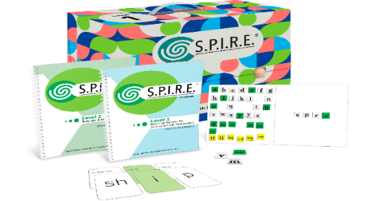
This resource provides recommendations on what you can do to save your data, why you might archive your classes, and other FAQ’s.
The EPS Team would also appreciate your feedback on how they have supported you with the implementation of SPIRE this school year. Please take a moment to share your thoughts. It is only 6 questions!
Teacher End-of-Year Survey
We and your students truly appreciate all you do.
Thank you,

