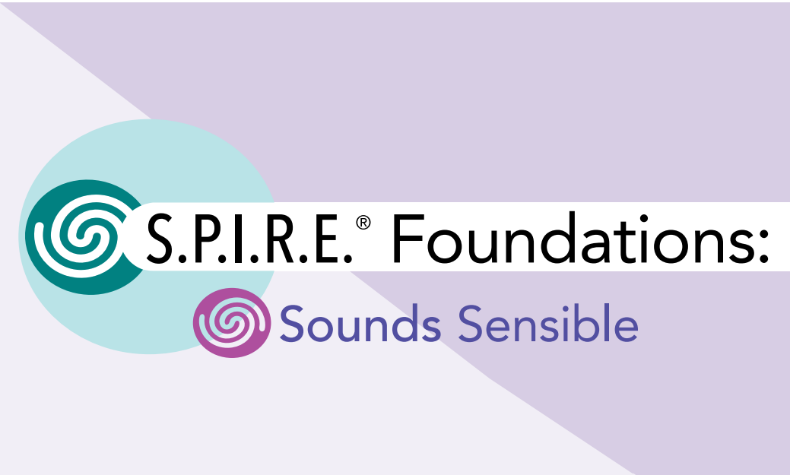
Dear Parents and Guardians,
This year, our district will be implementing the S.P.I.R.E. Foundations: Sounds Sensible Program — an essential and engaging way to strengthen your child’s early reading, spelling, and writing skills.
S.P.I.R.E. Foundations: Sounds Sensible is a structured literacy program that focuses on phonemic awareness, phonics, and early word-building skills. It uses multisensory activities so children can see, hear, say, and do as they learn. Children will work with letter tiles, picture cues, and hands-on activities to connect sounds to symbols, blend sounds to make words, and develop their early spelling patterns.
Why it’s important: Research shows that strong phonemic awareness is a key predictor of future reading success. This program helps your child:
- Hear and identify individual sounds in words
- Match sounds to letters and letter combinations
- Blend and segment words
- Build spelling and decoding skills that will support confident reading
How you can help at home:
- Play rhyming games in the car or at the dinner table.
- Practice reading together every day — let your child sound out words.
- Encourage your child to notice letters and sounds in everyday life (e.g., on signs, labels, or menus).
- Celebrate every effort your child makes as a reader and writer.
We are excited to see the progress your child will make as a growing reader. If you have questions about the S.P.I.R.E. Foundations: Sounds Sensible Program or ways you can support your child’s learning at home, please feel free to contact us or visit: https://www.epslearning.com/products/spire-foundations
Thank you for your partnership in your child’s education.
Sincerely,

